**1)What is Automation Testing?**

Automation Testing is the process of using software tools (like selenium) to run tests on applications automatically.

It checks whether the actual output matches the expected output, without manual efforts each time.

Example: Instead of clicking buttons or entering data manually every time, a script does it for you.

**2)Which are the Browsers Supported by Selenium IDE?**

Selenium IDE supports:

* Google Chrome
* Mozilla Firefox

Note: Selenium IDE is mainly used as a browser extension in Chrome and Firefox

**3)What are the Benefits of Automation Testing?**

* Saves Time: Faster than manual testing
* Reuseable: Test scripts
* Accuracy: Reduces human errors
* Supports Repeated Execution: Ideal for regression testing
* Increase Test Coverage
* Cost-effective in the long run

**4)What are the Advantages of Selenium?**

* Open-source and free
* Support multiple browsers (Chrome. Firefox, Edge, Safari)
* Support multiple languages (Java, Python, C#, etc.)
* Cross-platform testing (Windows, macOS, Linux)
* Can be integrated with testing tools Like TestNG, Junit, Maven, Jenkins
* Large community support

**5)Why Should Testers opt for Selenium Instead of QTP?**

**1)Cost-Effective**

Selenium is open source and free to use

QTP is paid tool by Micro Focus, which requires a license.

**2)Cross Browser Support**

Selenium supports Chrome, Firefox, Safari, Edge Opera etc.

QTP mainly supports Internal Explorer (limited browser support).

**3)Multi-language support**

Selenium supports multiple programming languages like Java, Python, C#, Ruby, JavaScript, etc.

QTP only supports VBScript.

**4)Platform Independent**

Selenium runs on Windows, macOS, Linux.

QTP works only on Windows.

**5)Community and Integration**

Selenium has large community and integrates well with tools like TestNG, Maven, Jenkins, Git,

QTP has limited integration and a smaller user community.

**6)Better for Web Testing**

Selenium is built for web application testing

QTP is heavier and mainly used for desktop apps or older enterprise systems.

**6) To validate the tops technologies website Contact us page and enter your friend detail at last “Login and side menu” Sauce demo website.**

**1)Tops Technologies Contact Us Page**

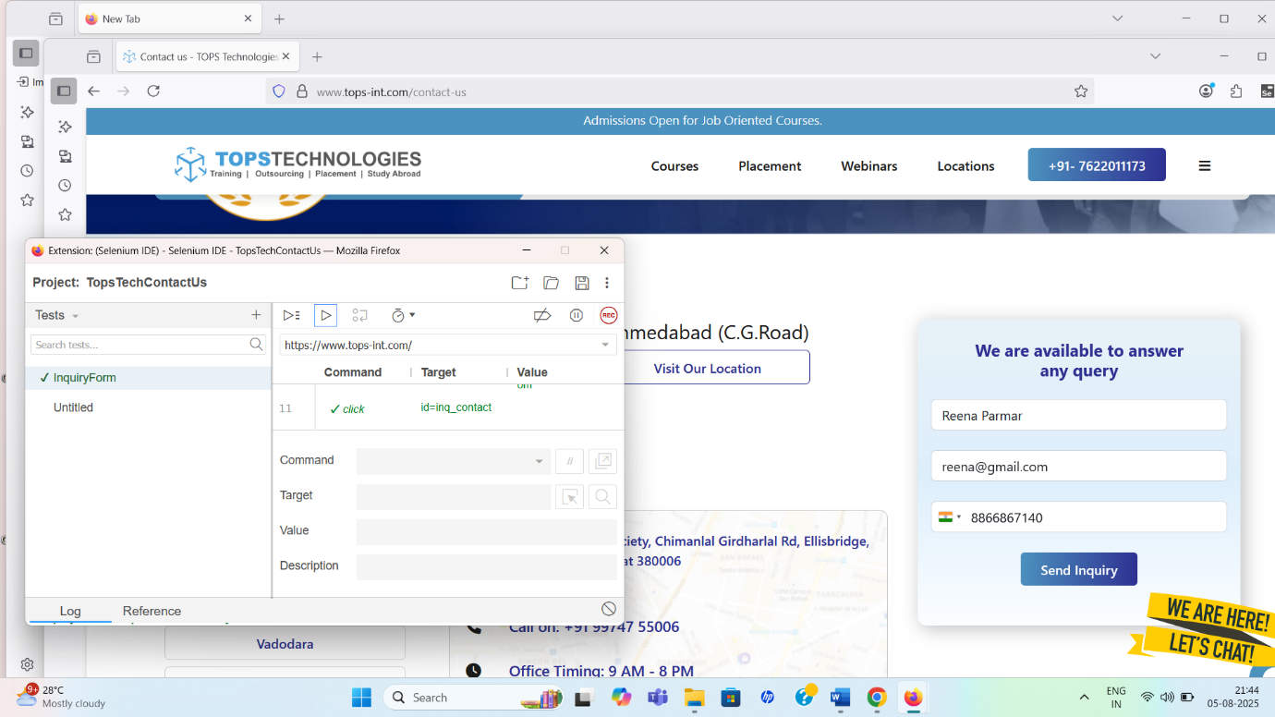

[**“Tops Technologies Contact Us page”**](https://github.com/SnehalSnehal28/Testing/blob/main/TopsTechContactUs.side)

**2) Sauce Demo Website**

**i) Sauce Demo Login Menu**

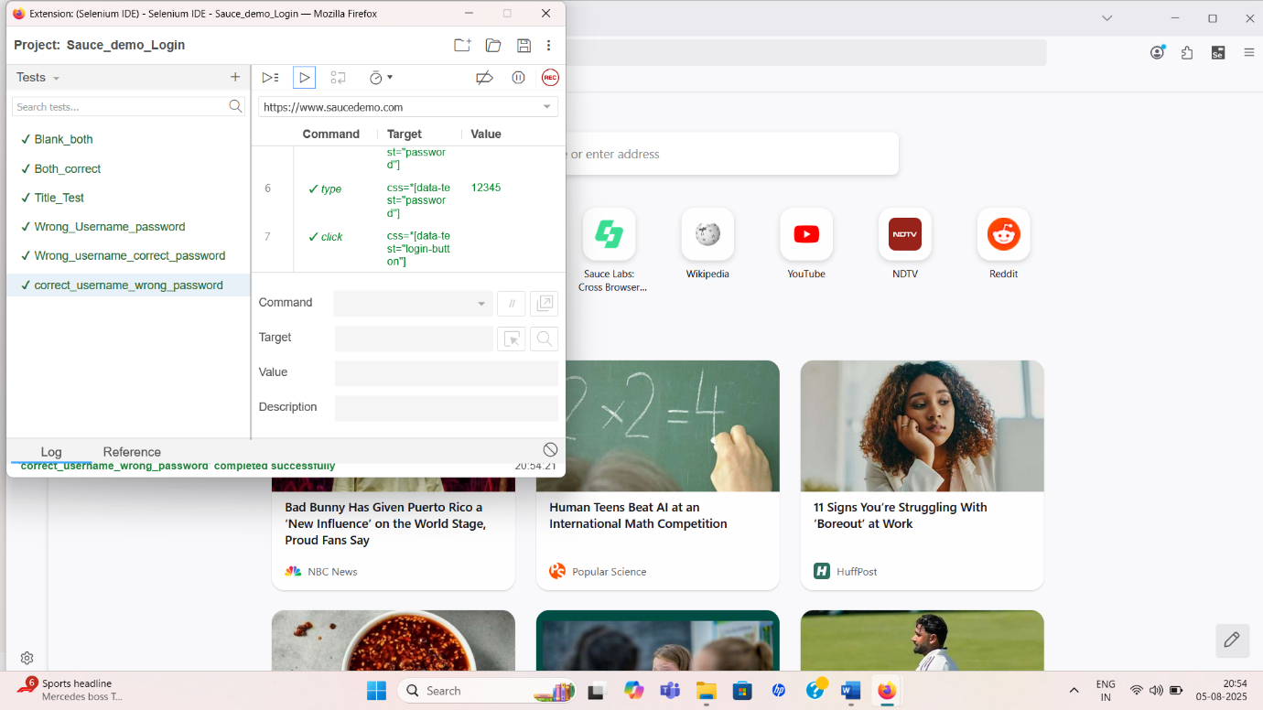

**[“Sauce Demo Login Menu”](https://github.com/SnehalSnehal28/Testing/blob/main/Sauce_demo_Login.side)**

**ii) Sauce Demo Side Menu**

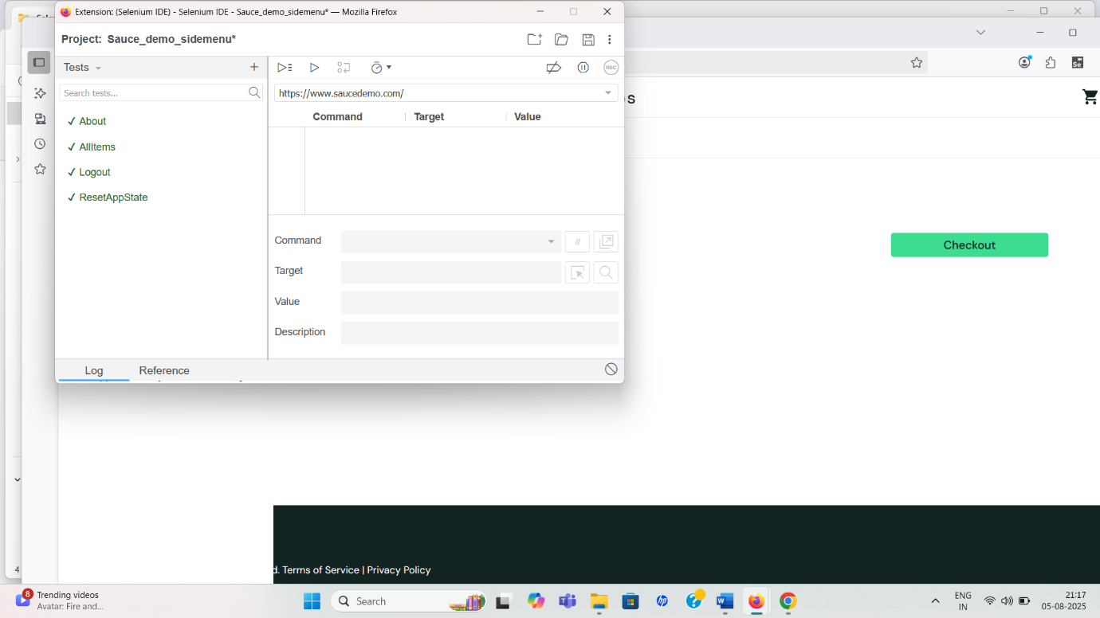

[**“Sauce Demo Side Menu”**](https://github.com/SnehalSnehal28/Testing/blob/main/Sauce_demo_sidemenu.side)